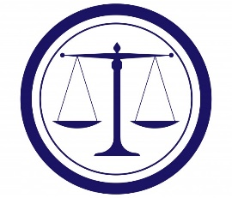
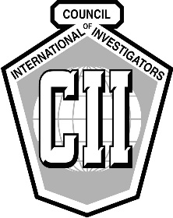
Council of International Investigators
2019 US Regional Meeting & Symposium
Wrongful Conviction Investigations
and Civil Rights Litigation
May 3 – 4, Chicago IL
Chicago 2019 Regional Meeting Registration

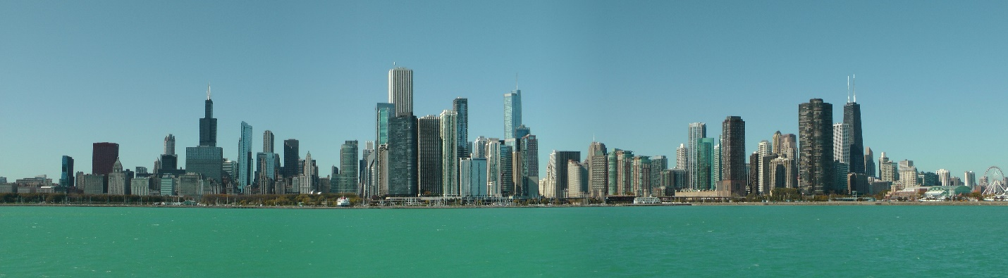

OVERVIEW
This regional meeting is open to all CII members and friends. It is going to be a combination of education, networking, and good old fashion fun! Our venue is the famous Whitehall Hotel, at the heart of Chicago’s Gold Coast. Jack Burke negotiated an unbelievable rate of $169 per night (plus tax) at this amazing boutique hotel. President David MacLeod is going to be there all the way from Australia so how about you?
The Education will be focused on wrongful conviction investigations & subsequent civil rights cases. Experts will discuss how and why the innocent are convicted; how investigators can make a difference; and real-life examples of investigative techniques that have not only exonerated the innocent but secured convictions of the true perpetrator. The Civil Rights portion will discuss the elements necessary to prove a civil rights violation and the investigator’s roll in those cases. Expert presenters will include attorneys and investigators who have a history of success in these cases, sharing their knowledge in what is an explosive field for investigators and lawyers.

The Networking will be in the true sense of a CII meeting with an opening cocktail reception; pizza party and drinks at the famous Pizzeria Due (chance to dine on Chicago’s famous deep- dish pizza); continental breakfast and lunch on seminar day. Saturday afternoon will offer attendees the time to take a walking tour of downtown Chicago and the Magnificent Mile; shopping on the Gold Coast; an architectural river cruise up the Chicago River; and we are working on a possible boat cruise on Lake Michigan. Finally, we have secured 20 box seat tickets for the Chicago White Sox versus the Boston Red Sox for Saturday night. If we need more tickets, we will score those too. Sox Park has some of the best ball park food imaginable and there will be fireworks after the game.
The Old Fashion Fun will be guaranteed with just the right CII mix of serious business; education; great food; outstanding comradery; a few cocktails; and plenty of stories.
AGENDA & SPEAKERS
FRIDAY, MAY 3, 2019
· Opening Cocktail Reception at the elegant Whitehall 5:30 PM to 7:30 PM
· Pizza Party at Pizzeria Due (famous Chicago deep dish pizza) 8 PM to 9:30 PM
· Hospitality Suite 10 PM—??
SATURDAY, MAY 4, 2019
· Symposium speakers & topics 8:00 AM to 2 PM
(includes continental breakfast, coffee breaks and lunch)
Ryan Ferguson—whose wrongful conviction and subsequent exoneration has been featured on 48 Hours; Dateline; countless print publications; and in a feature length film, “Dream Killer”, which debuted at the Tribeca Film Fest and is currently on Amazon steaming, tells of his case and the efforts it took to free him.
Bob Milan, Frank Himel, & Paul DeLuca—Three high profile Chicago based criminal defense attorneys (all former prosecutors) will participate in a panel discussion of how and why wrongful convictions occur; how to identify the elements of a wrongful conviction; identifying false confessions; how lawyers and investigators can work to overturn travesties of justice; and the difficulties in righting these wrongs.
Mike Robbins & Jeff Neslund—Two prominent civil rights attorneys, both former prosecutors, who secured a $5M pre trial judgement in the infamous Laquan MacDonald case, will explain the elements of a successful civil rights case and the investigator’s role in investigating police & prosecutorial misconduct.
Jim Kirby, Brian King, and Jeff Stein—Three CII members and each an experienced criminal defense investigator, will examine effective methodology in wrongful conviction and civil rights investigations, including, crime scene analysis; effective interviewing prosecution witnesses; use of media; FOIA requests; and other elements of investigation, all of which are critical in freeing the innocent. Each will share real case examples of how their work was able to help overturn clearly wrongful guilty verdicts.
· Various outings in Chicago for non seminar attendees 10 AM to 4 PM
(Walking tours; museums; architectural river tour; shopping and more)
· Chicago White Sox vs. Boston Red Sox outing 5:00 PM to 10:30 PM
· Hospitality Suite (after the ballgame)

HOTEL VENUE
The Whitehall Hotel
105 East Delaware Place
Chicago IL
312-573-6250
www.thewhitehallhotel.com
Room rates $169 per night + tax
Hotel registration link: Whitehall_Hotel_Registration

FEES
Full registration is $150 USD, which includes cocktail reception, pizza dinner; seminars; continental breakfast; buffet lunch
Spouse / Partner registration is $100 USD, which includes cocktail reception, pizza dinner; seminars; buffet lunch
Seminar Only Package is $125 USD
Whites Sox outing tickets extra at $40 USD
Click here to register now! Chicago 2019 Regional Meeting Registration

